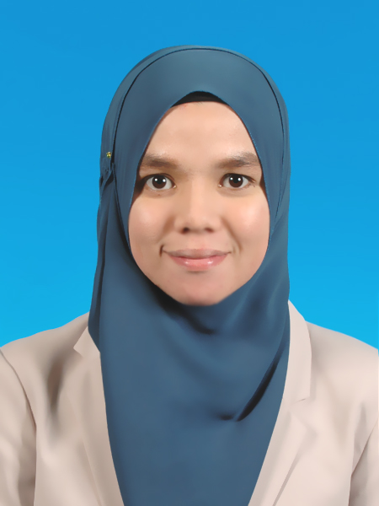
NOOR ARNISSA BINTI ABDULLAH
Degree in Business Management (Islamic Banking)

Date of Birth: 10th December 1991 (23 Years)
Email id: aneesaelysa91@yahoo.com
Mobile No.: 019-6356533.
Gender: Female
Marital Status: Single.
Present Address: 3-1, Jalan 10D, Taman Setapak Indah, 53300 Kuala Lumpur, Malaysia

OBJECTIVES

- To apply for internship with your company.
- To gain work experience before facing the real work challenges.
ACADEMICS

Level | Institute | Board/University | Result. | Year
Degree. | University Technology of Mara (UiTM Puncak Alam Campus) (On going) | Malaysia. | Current CGPA: 2.5. | 2012-Current
STPM. | SMK Paya Besar, Kuantan Pahang. | Malaysia. | 2B 2C. | 2009-2010
ACHIEVEMENT

EVENT | ACHIEVEMENT
- Participate in Al-Quran Recitation Competition under UITM 2012. | 4th Place
- Participate in Poem National Day Competition 2013 | 5th Place
- Participate in Syair Competition under Cultural Centre of UITM 2013. | 6th Place
- Participate in “Hijabista-Ri” Competition Talk under UITM | 3rd Place
- Participate in Poem Declamation under UITM September 2014. | 1st Place
- Participate in UITM Debate Competition 2014. | 4th Place
- Participate in UITM National Declamation of Poem Competition 2015 | 2nd Place.

SKILLS

Proficiency (0=Poor - 10=Excellent)
Language | Spoken | Written
Malay | 10 | 10
English | 08 | 09

Software | Skill
- Microsoft Office  Word, Power Point, Excel, | 08
- Multimedia  Window Movie Maker (Basic) | 06

Extra-Curricular Activities

EVENT | POSITION | DESCRIPTION
- “Global Outreach Programme to Hong Kong” for Islamic Banking (Masters and Degree Students) August 2014. | Committee and  Organizer | - Promoting Islamic banking  - Emcee in Uthman Ramju  Saddiq Mosque  - Meeting with Maybank of  Hong Kong  - Visiting Kim Eng.  Securities  - Visiting Hong Kong  Monetory  - Visiting Konsulat Jeneral  Malaysia of Hong Kong
- Fund raising and Poet for Malaysian Consultative Council of Islamic Organization (MAPIM). (2014-Currently). | Volunteer.  Poet. | - Speak in audiences  - Participate in many events.  - Fund Raising.
- A Participant of I-Bank Le Tour De Merbok (Al-Quran reciter) | Participant. | - Al-Quran Reciter for  Dinner programme and  participate in organized  activities
- As a Committee in organized “Annual Grand Meeting (AGM)” for Islamic Banking 2013 | Committee. | - Provide the programme  tentative.
- As a committee in organized Seminar “Connecting Shariah Compliance to the Risk Taking” 2014. | Committee. | - Preparing programme’s tentative
- As a 3 days Emcee and as a Committee for 2nd National Financial Planning Council (MFPC) 2014. | Committee. | - At as an Emcee  - Perform as a Poet
- As a Committee for Hostel “Kolej Mawar” UiTM Shah Alam | Committee. | - Report on any problems existed and organized  events.
- Community Service for “Orang Asli” in Selangor. | Committee. | - Helping with their needs
- Participate in UITM REUMMAHFICATION 2.0 Programme. | Participant.  (Poet) | - Delivered an Islamic poem  In front of the audience.  - Orphanage Community Service  Programme.  - “Muallaf” forum programme.
- Participate in UITM “Pengurusan Jenazah” Programme. 2015 | Participant.  (Poet) | - Be as a model.
- Participate in UITM “Rasulullah is my Idol” with Da’i Wan Dazrin, 2015. | Participant. | - Delivered an islamic english poem for opening.

WORKING EXPERIENCES

EXPERIENCES | YEAR
Part-time as an Assistant in Clothing Boutique in Kuantan. | 2010
Working as a Teacher in An-Nur  Pre-Tahfiz School. | 2010
Working in Seri Idola Cosmetics Company as a Consultant and Assistant part-time. | 2010
Experience as a part-time Baby Sitter in  Taska Aqib and Atiq in Shah Alam. | 2010
Experience as a part-time Baby Sitter in  Taska Bistari in Taman TTDI Shah Alam. | 2013
As a Part-time Poet for over 20 Events  (Currently). | 2014-Now

REFERENCES

Name  Telephone  Position  Company | :  :  :  :  : | Mr. Ahmanul Mohd Taib.  017-6514591.  Lecturer  Faculty of Business Management  University Teknologi MARA, (UiTM)  40450 Shah Alam, Selangor.
Name  Telephone  Email  Position  Company | :  :  :  :  : | Mohamad Asmady bin Shahadan  018-6688446  asmadyuitm@yahoo.co.uk  Lecturer.  Faculty of Business Management  University Teknologi MARA, (UiTM)  40450 Shah Alam, Selangor

I confirm that, the above information is true and correct to the best of my knowledge.
Date: 27th May 2015.

Dear Hiring Manager,
Internship Program 27th May 2015.

Dear Sir/Madam,

APPLICATION FOR PRACTICAL TRAINING PLACEMENT.

Currently I am a final years at UiTM Campus Puncak Alam and as a required to fulfill the UiTM bachelor program, I need to do an industrial practical training for 17 weeks beginning 3nd August 2015 until 27th November 2015.

Name | Student No. | Program
Noor Arnissa Binti Abdullah | 2011159739 | Islamic Banking

I believe if I’m given the opportunity to do practical training in your company, it will help me to gain experiences, knowledge and also will help to improve my soft skills. This is because, for me your company is among the best companies present, and are an established company for this industry. If your company give me opportunities in finishing my practical training plus completing my project paper, I’m willing to learn something new without any excused.

I would be extremely grateful if you kindly considered me to be part of your company. Kindly respond me through my email, aneesaelysa91@yahoo.com or contact me through my mobile phone, 019-6356533.

Thank you for your cooperation, commitment and support.

Yours sincerely,
NOOR ARNISSA BINTI ABDULLAH.

